H.T No
Regulations:
A14

Sreenidhi Institute of Science and Technology
(An Autonomous Institution)
Code No: 4CC04 Date: 10-Aug-2023 (FN)

B.Tech II-Year I- Semester External Examination, Aug - 2023 (Supplementary)
Signals and Systems (ECE)

Time: 3 Hours Max.Marks:70

Note: a) No additional answer sheets will be provided.
b) All sub-parts of a question must be answered at one place only, otherwise it will not be valued.
c) Missing data can be assumed suitably.

Bloom's Cognitive Levels of Learning (BCLL)

Remember | L1 | Apply | L3 | Evaluate | L5
Understand | L2 | Analyze | L4 | Create | L6

Part - A Max.Marks:20
Answer all QUESTIONS

 |  | BCLL | CO(s) | Marks
1 | What is meant by orthogonal signal space? | L1 | CO1 | [2M]
2 | What is meant by Fourier Spectrum? | L1 | CO2 | [2M]
3 | Distinguish Linear Time Invariant and Linear Time Variant Systems. | L4 | CO3 | [2M]
4 | Write the expression for Autocorrelation. | L1 | CO4 | [2M]
5 | Write the statement of Sampling Theorem. | L1 | CO5 | [2M]
6 | Write the Methods of finding Inverse Z-Transform. | L1 | CO6 | [2M]
7 | Describe Hilbert Transform. | L1 | CO2 | [2M]
8 | How transfer function of an LTI System is represented? | L1 | CO3 | [2M]
9 | What is meant by Aliasing Effect? | L1 | CO5 | [2M]
10 | How periodic signals are detected in the presence of Noise? | L2 | CO4 | [2M]
Part – B Max.Marks:50
ANSWER ANY FIVE QUESTIONS. EACH QUESTION CARRIES 10 MARKS.

 |  |  | BCLL | CO(s) | Marks
11. | a) | Explain how a signal can be approximated by a set of Mutually Orthogonal Functions. | L3 | CO1 | [5M]
 | b) | Explain the following Signals  - Energy signal and Power signals (ii)Periodic and Aperiodic Signals  (iii) Deterministic and Random Signals | L2 | CO1 | [5M]
12. |  | Obtain the Fourier components of the periodic rectangular wave form given below.  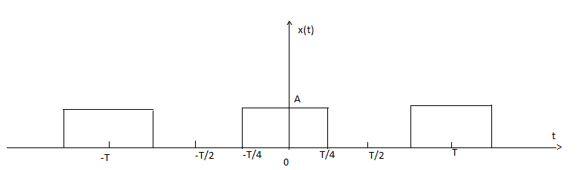 | L2 | CO2 | [10M]
13. | a) | Explain about distortion less transmission Through a system. | L3 | CO3 | [5M]
 | b) | Explain the relationship between bandwidth and Rise Time. | L3 | CO3 | [5M]
14. | a) | Explain how convolution is performed using Graphical procedure. | L3 | CO4 | [5M]
 | b) | The input and the impulse response to the system are given by x(t)=u(t+2) and h(t)=u(t-3). Determine the output of the system. | L3 | CO4 | [5M]
15. | a) | State and prove Sampling theorem. | L2 | CO5 | [5M]
 | b) | A signal x(t)=2cos 400 πt +6cos640 πt is ideally sampled at fs=500Hz. If the sampled signal is passed through an ideal LPF with a cutoff frequency of 400Hz, what frequency components will appear in the output? Sketch the output Spectrum? | L3 | CO5 | [5M]
16. | a) | Derive the relation between Laplace and Z-Transform. | L4 | CO6 | [5M]
 | b) | Prove that the sequences  i)x(n)=a^{n}u(n) ii) x(n)-a^{n}u(-n-1) have the same X(z) and differ only in ROC. Also plot their ROCs. | L3 | CO6 | [5M]
17. | a) | Explain the analogy between Vectors and Signals. | L3 | CO1 | [4M]
 | b) | Find the fourier transform of rectangular pulse of duration T and amplitude A. | L3 | CO2 | [3M]
 | c) | Explain significance of paley-Wiener criterion for Physical Realizability. | L4 | CO3 | [3M]
18. | a) | Explain initial and final value theorems Using Laplace Transform. | L2 | CO4 | [4M]
 | b) | Explain about Flat top Sampling. | L3 | CO5 | [3M]
 | c) | Explain constraints on ROC for various classes of signals. | L2 | CO6 | [3M]
-- 00 -- 00 –

